
IBM Proposal for
Gap NSI Reporting and Analytics Solution

Presented to Gap Inc.
By IBM Business Consulting Services
425 Market Street
San Francisco, CA 94105

Disclosure Statement
The information in this document shall not be disclosed outside the Gap Inc. and shall not be duplicated, used or disclosed in whole or in part for the purpose other than to evaluate the proposal, provided that if a contract is awarded to IBM as a result of or in connection with the submission of this proposal, Gap Inc. shall have the right to duplicate, use or disclose the information to the extent provided in the contract. This restriction does not limit the right of Gap Inc. to use information contained in the proposal if it is obtained from another source without restriction. IBM retains ownership of this document
Document Purpose
The information in this document is for discussion purposes only. Pending review, IBM will prepare and submit Statement of Work consistent with the terms of the Gap Master Services Agreement. Until a Statement of Work is submitted all description of services and fees are non-binding to Gap and IBM respectively.

Table of Contents

Executive Summary 2
1 Project Description and Scope 4
2 IBM Approach 5
2.1 Overview 5
2.2 Project Management 5
2.3 BI Strategy and Planning 6
2.3.1 Review Gap Business and IT Environment 6
2.3.2 Identify Solution Areas 6
2.3.3 Define Business Solution Strategy 7
2.3.4 Define Technical Solution Strategy 7
2.3.5 Outline Architecture Model 7
2.3.6 Assess Infrastructure Impact 8
2.3.7 Confirm BI Strategy and Planning 8
2.4 Solution Outline 8
2.4.1 Define Infrastructure Requirements 8
2.4.2 Define Architecture Model 8
2.4.3 Define Organization 9
2.4.4 Review Gap Environment 9
2.4.5 Outline Solution Requirements 10
2.4.6 Outline Application Model 10
2.4.7 Assess Business Impact 10
2.4.8 Outline the Solution Strategy 10
2.4.9 Solution Validation Workshop 11
2.4.10 Confirm Solution Outline 11
2.5 Macro Design 12
2.5.1 Design Logical Data Repositories 12
2.5.2 Create Logical Data Integration Design 12
2.5.3 Create Logical Analytics Design 12
2.5.4 Create Logical Access Design 13
2.5.5 Design the Architecture Model 13
2.5.6 Design Solution Plans 13
2.5.7 Design Test Specifications 14
3 Project Timeline 15
4 Pricing, Project Assumptions, and Resource Plan 16
4.1 Project Pricing Estimates 16
4.2 Project Assumptions 17
4.3 IBM Resources and Role Descriptions 18
4.4 Project Resource Organizational Diagram 19

Executive Summary
IBM is pleased to present our response to Gap’s request for assistance on the New Strategic Initiative (NSI) Reporting and Analytics project. It is our understanding that this environment is to be designed and implemented to provide Gap with a common source of data, beginning with a consolidated view of store information and associated reporting for European Stores with additional analytics and reporting capability to be implemented for Europe and eventually additional countries. The architecture to be deployed must address the short term reporting needs while also establishing the foundation for Gap’s long term data warehousing and Business Intelligence objectives.
- Gap has defined the high level vision for its next generation data warehouse capability and the architecture toward which it intends to migrate over a multi-year timeframe in support of the New Strategic Initiative Project. The Gap leadership team recognizes the importance of devising a well-formed and sustainable Data Warehouse/Business Intelligence (DW/BI) architecture to support, not only the immediate needs of the business under NSI, but also the next generation of data warehousing at Gap that will enable cross business and country integration.

- As you will see in the details of our response, IBM is proposing to provide several key capabilities that together, will enable Gap to achieve both their short and longer term objectives. These capabilities include:
- An experienced team consisting of professionals from our business services and software teams that know your business, current information technology environment and where you want to go
- A proven methodology and approach to implementing retail industry specific business intelligence solutions
- Tools and technology that will enable the deployment of an integrated end-to-end architecture that can quickly address the current reporting issues while establishing a foundation that can be built upon to support longer term objectives
- Industry leading Business Intelligence capability that will allow us to present Gap with multiple options that will help Gap make informed decisions that better align with cost and benefit drivers.
- Implementation capabilities that will enable us to design the architecture allowing Gap to realize business benefits with less risk.

In addition to these capabilities, several differentiators unique to IBM and our willingness to partner, will provide Gap with an accelerated approach with less risk. These differentiators include the following:

- Knowledge of IBM’s Retail Business Intelligence Solution (RBIS) model which will be used as a comparison and validation of business requirements by conducting a workshop subsequent to the end-to-end requirements sessions to validate the Gap requirements and solution approach. The RBIS can be a key accelerator that will change the traditional paradigm of requirements gathering to one that gets the organization to quickly focus on Gap’s specific requirements. The Workshop is part of IBM’s investment in the success of the Gap NSI Reporting and Analytics Solution

- A target architecture review using evaluation of Gap current infrastructure mapped against IBM’s BI reference architecture to help identify areas to lower cost and avoid risk.

- A team with knowledge and experience across the key areas is critical to this engagement. This knowledge includes but is not limited to the technology and tools required to enable the architecture, understanding of the business issues facing the retail industry which we will provide through our industry based intellectual capital and research as well as functional knowledge of the subject areas being addressed by this project.

- Provide subject matter experienced resources to assist in the requirements gathering workshops. The effort of the Subject Matter Experts is part of IBM’s investment in the success of the Gap NSI Reporting and Analytics Solution

- Provide Todd Bixby, The Partner in charge of IBM’s Retail Business Intelligence Consulting Practice, with over 18 years of experience deploying business intelligence, reporting and data warehouse solutions will provide leadership and advise the delivery team through implementation. Todd’s experience includes projects with several large retail organizations including Starbucks, McDonald’s, Target, and Radio Shack. Todd’s effort is part of IBM’s investment in the success of the Gap NSI Reporting and Analytics Solution

In summary, based on our work with the NSI reporting and analytics team to-date, and our knowledge of your business and technical environment, we are proposing an approach that can significantly reduce Gap’s risks in meeting the aggressive timelines and business requirements of NSI.

Project Description and Scope
Gap Inc. is evaluating potential partners to provide consulting services and solutions in support of the design of an overall reporting and analytic information architecture framework that supports the NSI Merchandising Footprint. The Plan is to improve the usability and availability of data associated with the NSI rollout for Gap. The selected partner will assist with the planning, and design of the overall Enterprise Reporting and Analytics Architecture. The partner will assist in reviewing architecture, facilitating requirements gathering and provide assistance in the development of other key deliverables outlined within this document.
Specifically, the goals of the project are to design a robust and flexible architecture for the NSI Reporting and Analytics which will support business requirements with the Process areas included under Phase 1 and Phase 2 of The NSI rollout:
Phase 1:
- Retail Operations
- Customer Transactions
- Store Management
- Store Inventory Management
- Financial and Inventory Accounting
- Inbound Logistics
Phase 2:
- Planning
- In Season Management
- Allocation

Our Approach will be based on IBM’s standard Business Intelligence Methodology that has been used on many customer engagements for the design and deployment of a Enterprise reporting and analytics solutions. The Scope includes activities in the BI Strategy and Planning, Solution Outline, and Macro Design phases of the IBM Global BI Method. We have customized our methodology to meet Gap’s specific requirements and to specifically integrate our approach with efforts already underway at Gap. A detailed discussion of our approach is included in the following section.

IBM Approach

Overview
IBM understands the project goals, objectives and will continue to work with Gap to define the scope. We have provided an approach that will assist Gap in achieving the objectives of the project with lower overall risk. IBM’s approach to designing and developing BI solutions is multi-phased; each phase building upon those that preceded it. The major activities of our standard approach across the entire BI project lifecycle are depicted in the figure below for completeness and although are represented in sequential fashion, our detailed methodology, workplans and sample deliverables allow us to execute many activities in parallel. The Scope includes activities in the BI Strategy and Planning, Solution Outline, and Macro Design phases of the IBM Global BI Method as depicted within the red box below.

Standard Methodology
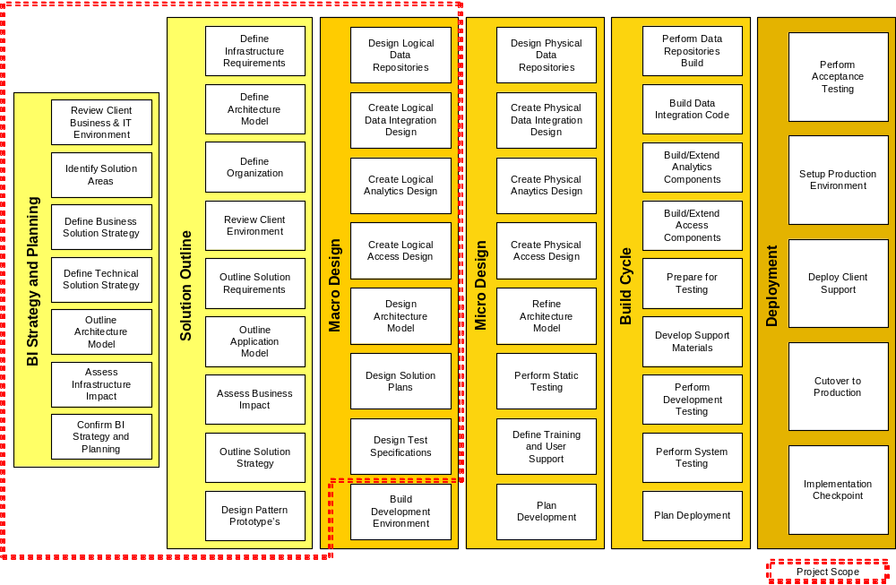
We have customized our methodology to meet Gap’s requirements and to specifically integrate our approach with efforts already underway at Gap. A detailed outline of the activities follows:

Project Management
IBM anticipates providing project management for the IBM responsibilities and resources. The purpose of this activity is to provide technical direction and control of IBM project personnel and to provide a framework for project planning, communications, reporting, procedural and contractual activity. IBM will perform the following tasks:
Planning
- Review the Statement of Work and the contractual responsibilities of both parties with Gap Project Manager.
- Maintain project communications through Gap Project Manager.
- Coordinate the establishment of the project environment.
- Establish documentation and procedural standards for Deliverables.
- Prepare and maintain the project plans for performance of this Statement of Work, which defines the activity, task, responsibilities, milestones and estimated schedule.
- Prepare for the NSI Reporting and Analytics project team orientation.
Project Tracking and Reporting
- Measure and evaluate progress against the Project Plan with Gap project manager.
- Resolve deviations from the Project Plan with Gap Project Manager.
- Conduct regularly scheduled project status meetings.
- Prepare and submit a Status Report bi-weekly to Gap project manager.
- Administer the Project Change Control Procedure with Gap project manager.
- Coordinate and manage the technical activities of the project personnel.
- Review project tasks, schedules, and resources and make changes or additions, as appropriate.
Deliverables:
- Bi-weekly Status Reports

BI Strategy and Planning

Review Gap Business and IT Environment
The purpose of this activity is to review existing documentation of client strategies, initiatives, systems etc in order to gain an understanding of the business, organization, and IT environment in preparation for identifying BI opportunities and developing several solution areas.
Based on the interviews conducted, IBM will work with Gap to perform the following:
- Define Business Context (Interviews, workshops, research)
- Identify High Level Business Requirements
- Define Business Issues and Goals
Deliverables:
- High-Level Current Environment Assessment and Comment

Identify Solution Areas
The purpose of this activity is to identify one or more solution areas, where each solution area represents a discrete project initiative with its own set of objectives, scope and intent. There is an initial prioritization of each defined solution area based on its relative importance and benefit to the business.
IBM will develop an NSI Reporting and Analytics Solution Strategy document which outlines the following:
- Identify Opportunities and Desired Capabilities
- Outline Capability Enablers
- Identify Capability Gaps Shortcomings and Deficiencies
- Outline High Level Subject Area Model (BI)
- Outline Solution Areas
Deliverables:
- High-level Subject Area Model

Define Business Solution Strategy
The purpose of this activity is to define the overall solution strategy based on the set of specific solution areas that offer value. This activity is performed in order to assemble the solution strategy according to solution area.
IBM will develop a NSI Reporting and Analytics Solution Strategy document which outlines the following:
- Define Solution Area Impact
- Develop Solution Area Release Plan (Roadmap)
Deliverables:
- Solution Definition, Solution Roadmap

Define Technical Solution Strategy
The purpose of this activity is to capture decisions about how business processes will be supported, identifies the scope of the system, and outlines infrastructure requirements.
The IBM team will perform the following:
- Outline User Profiles
- Outline Metadata Strategy
- Refine Subject Area Model (BI)
- High-Level Review of Data Availability and Quality
- Review External Data Reference Definition
- Define and Categorize Infrastructure Requirements
Deliverables:
- Review and Comment on Technical Solution Strategy

Outline Architecture Model
The purpose of this activity is to define a high-level draft of the architecture and establish a framework which guides the implementation of business intelligence solutions. It serves as the basis for the evaluation and planning of the end-state infrastructure. It ensures that the architecture is robust and flexible for the overall systems (all releases), which can easily adapt to changing business requirements.
The IBM team will perform the following:
- Review High-Level Architecture Overview
- Review High-Level Component Model
- Review High-Level Operational Model
- Review Service Levels
- Reference Architecture Asset Gap Analysis
Deliverables:
- Review and Comment on Reference Architecture

Assess Infrastructure Impact
The purpose of this activity is to identify the gaps between the existing and required technologies, networks, IT processes, and IT skill sets, in terms of how they perform today and how likely they will meet the future business needs. This information is an essential prerequisite in planning the activities to build and support the future IT infrastructure.
The specific tasks to be performed by IBM in this activity are defined in the sections below:
- Confirm Solution Areas Post Infrastructure Planning Impact
- Confirm Solution Area Release Plan
Deliverables
- High-Level BI Roadmap for NSI

Confirm BI Strategy and Planning
The purpose of this activity is to develop the overall strategy for moving forward with the solution outline, design and development effort, and gain client agreement to a BI Strategy and Plan (roadmap).
The specific tasks to be performed by IBM in this activity are defined in the sections below:
- Assemble Phase Deliverables
- Review Phase Deliverables
- Prepare Submission of Deliverables
- Harvest Reusable Assets
- Manage Acceptance
Deliverables
- High-Level BI Strategy for NSI

Solution Outline

Define Infrastructure Requirements
The purpose of this activity is to outline the requirements for the system and ensure that all future decisions reflect the business priorities.
The specific tasks to be performed by IBM in this activity are defined in the sections below:
- Develop Metadata Strategy
- Refine Subject Area Model (BI)
Deliverables:
- Metadata Strategy
- Provide feedback on current Architecture Model (Document)

Define Architecture Model
The objective of this activity is to formulate a high level, conceptual vision of the architecture for the overall NSI Reporting and Analytics Solution. It will ensure that the architecture is robust and flexible for the overall systems (all releases), which can easily adapt to changing business requirements, ensure that the architectural solution can meet business requirements and non-functional requirements, and provide a basis for detailed estimation and planning of the end-state infrastructure.
The specific tasks to be performed by IBM in this activity are defined in the sections below:
- Review Reusable Components/Templates
- Review the High-Level Component Model
- Review the High-Level Operational Model
- Review Architecture Overview
- Review Survey of Available Assets
- Review Service Level Analysis
- Review BI Reference Architecture Asset Gap Analysis
- Refine Viability Assessment
Deliverables:
- Provide feedback on current Architecture Model (Document)

Define Organization
The purpose of this activity is to identify the gaps between the existing and required business roles, technologies, networks, IT processes, and IT Roles, in terms of how they perform today and how likely they will meet the future business needs. This information is an essential prerequisite in planning the activities to build and support the future IT infrastructure.
The specific tasks to be performed by IBM in this activity are defined in the sections below:
- Review Organization Gap Analysis
- Review IT Readiness Assessment
- Review IT Organization Skills Gap Analysis
- Review Job Roles and Responsibilities and Competencies
- Review Model of Process Strategy and Approach (BI)
Deliverables:
- Review and Comment on IT Organizational Strategy

Review Gap Environment
The objective of this activity is to gain an understanding of Gap business, organization and current I/T environment in preparation for recommending the NSI Reporting and Analytics solution.
IBM will conduct 10 interviews with identified NSI Reporting and Analytics stakeholders, and facilitate the reporting portion of 12 End to End process workshops. The IBM Project Manager will work with Gap Project Manager to determine the actual interviews and workshops to be conducted.
The specific tasks to be performed by IBM in this activity are defined in the sections below:
- Classify Business Terms
- Define Business Context
- Obtain or Develop Business Models
- Validate Business Issues And Goals
- Document IT Standards
- Analyze Current IT Infrastructure as it relates to supporting the business requirements
Deliverables:
- Analytic Requirements from workshop as input into section 2.4.5

Outline Solution Requirements
The purpose of this activity is to outline the requirements for the system based upon the completed stakeholder interviews and end to and process workshops and ensure that all future decisions reflect the business priorities.
The specific tasks to be performed by IBM in this activity are defined in the sections below:
- Establish System Context
- Evaluate Current Solution
- Gather and Categorize Requirements
- Work on Key Use Cases
- Assess Initial Viability
Deliverables:
- Business and IT Requirements

Outline Application Model
The purpose of this activity is to help understand the complexity of the system.
The specific tasks to be performed by IBM in this activity are defined in the sections below:
- Establish Analysis Guidelines
- Define Conceptual Data Model
- Outline System Functions
- Outline Process/Data Usage Matrix
- Confirm External Data Reference Definition
- Assess Data Sources
Deliverables:
- Review Conceptual Data Model created by Gap
- Review Source System Inventory and Mapping created by Gap

Assess Business Impact
The purpose of this activity is to verify engagement feasibility (IBM "due diligence") and ensure the expected organization change is planned for and addressed in the later phases of the project.
The specific tasks to be performed by IBM in this activity are defined in the sections below:
- Develop Organization Change Readiness Assessment
- Develop IT Readiness Assessment
- Confirm Solution Area
Deliverables:
- Review and comment on the Organizational Strategy

Outline the Solution Strategy
The purpose of this activity is to ensure a shared understanding of the appropriate engagement process for the remaining phases, provide context and rational for the estimate, and provide a basis for planning of the development effort.
The specific tasks to be performed by IBM in this activity are defined in the sections below:
- Sketch Release Plan
- Sketch Deployment Plan
- Sketch System Management Plan
- Setup Configuration Management Procedures
- Define Test Strategy
- Review Education and Training Strategy
Deliverables:
- Assist in the development of the Deployment Plan
- Assist in the design of the Test Strategy
- Review and Comment on Education and Training Strategy

Solution Validation Workshop
IBM will perform a Solution Validation Workshop. The purpose of this activity is to validate Gap’s approach for subsequent project phases:
The specific tasks to be performed by IBM in this activity are defined in the sections below:
- Review the Gap Solution Strategy within the context of the IBM RBIS Solution Templates
- Facilitate an RBIS Workshop to validate the Gap BI Solution Strategy against the RBIS Solution Strategy
Deliverables
- RBIS Workshop

Confirm Solution Outline
The purposes of this activity are to re-estimate the project effort, package the major deliverables, identify any risks, verify that Gap is still committed to the remaining NSI Reporting and Analytics project efforts, and prepare the detailed project plan and budget for the Macro Design phase.
The specific tasks to be performed by IBM in this activity are defined in the sections below:
- Package all project Deliverables for final delivery
- Re-estimate the project efforts, and develop the project plan the Macro Design phase (Project Management Schedule, Project Estimates)
- Conduct a review of the project Deliverables and review the project status
Deliverables
- Create High Level Project Plan with identified dependencies

Macro Design

Design Logical Data Repositories
This activity defines the logical framework in terms of the short-term and long-term strategy for the logical data models (e.g. operational reporting databases to OLAP structures) necessary for the planned business intelligence environment.
IBM will work with Gap to:
- Review Logical Data Repositories Architecture
- Review High-Level Operational Data Store Logical Data Model
- Review High-Level Data Warehouse Logical Data Model
- Review High-Level Data Mart Logical Data Model
- Assist in developing DQ Criteria from the Logical Data Models
- Define the approach to Capture Logical Data Model(s) Business Metadata
Deliverables:
- Review and Provide input into Logical Subject Area Data Model
- Review and Provide input into Logical Data Repositories Architecture (DW, ODS, Data Marts)

Create Logical Data Integration Design
This activity defines the logical data integration specifications necessary to meet the business requirements of data integration and movement for both the short-term and long-term projects in terms of frequency, integration, and data quality, for the planned business intelligence environment.
IBM will work with Gap to:
- Review and Provide Input into Logical Data Integration Architecture
- Review and Provide Input into Logical Data Integration Model (e.g. Data Flow Diagram)
- Review and provide input into the approach to Source Data Quality
- Review Logical Transform Design
- Review Logical Load Design
- Review Data Conversion Approach
- Review Logical Source-To-Target Model Approach
- Provide input into design of Logical Data Integration Model Navigational Metadata
Deliverables:
- Review and provide input into Logical ETL/EAI Design
- Review and provide input into High Level Source data quality assessment
- Review and provide input into Data Transformation Business Rules (Business Rules Specification for KPI’s)
- Review and provide input into Logical Source-Target Mapping (Source level Data Mapping Analysis)

Create Logical Analytics Design
This activity defines the logical analytic specifications and/or prototype necessary to confirm the reporting, ad-hoc query, and analytic business requirements of planned business intelligence environment for both short-term and long-term projects.
IBM will work with Gap to:
- Establish Analytics Design Guidelines
- Review User Requirements
- Review Delivery Services Architecture
Deliverables:
- Provide input and guiding principles for Logical Analytics Design

Create Logical Access Design
This activity defines the logical access specifications in order to determine the access method (e.g. portal, web browser).
IBM will work with Gap to:
- Review Web Browser Approach
- Review Portal Approach
- Review Device Approach
- Review Access Architectural Models
Deliverables:
- Provide input into Logical Access Design

Design the Architecture Model
The purpose of this activity is to design a robust and flexible architecture for the overall system which will support business requirements and can easily adapt to changing business requirements, assess the viability of the system, provide a basis for detailed estimation and planning for the first release of the system, provide a basis for designing and implementing individual releases of the system, and avoid duplicate or "throw away" development effort within the releases by taking into account the dependencies between the functionality of the releases.
IBM will assist Gap in:
- Evaluating Candidate Assets
- Determining Deployment Units
- Reviewing Operational Model
- Providing Guidelines for Stereotypical Interactions
- Refine Architecture to Accommodate Change Cases
- Reference Architecture Asset Gap Analysis
- Evaluate Infrastructure Products
- Provide insight into alternative Infrastructure approaches

- Analyze and provide input int Service Levels (BI)

- Review IT Organization Skills Gap Analysis
Deliverables
- Metadata Environment approach and recommendations
- Organizational Recommendations

Design Solution Plans
This activity develops the system test plan, develops the usability and evaluation plan, develops at a high level the education and training plan, to include responsibilities and deliverables, and develops the deployment plan.
IBM will work with Gap to:
- Provide input into Release Plan
- Provide input into Education and Training Plan approach
- Review and provide input into Revised Deployment Plan
- Review and provide input into System Management Plan
- Review and provide input into Acceptance Test Plan approach
- Review and provide input into Operability Test Plan
- Review and provide input into Integration Test Plan
- Review and provide input into Develop System Test Plan

Deliverables:
- Assist in development of Refined Plans

Project Timeline
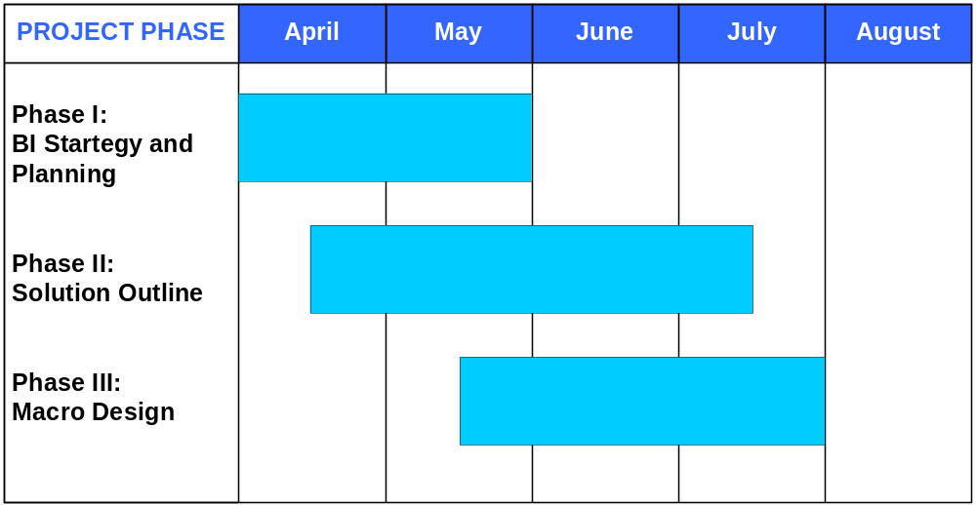

Pricing, Project Assumptions, and Resource Plan

Project Pricing Estimates
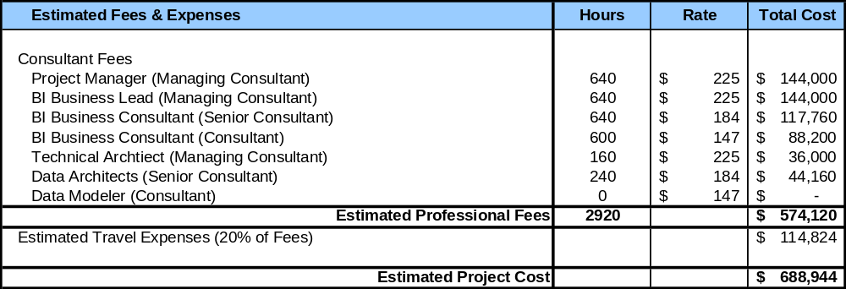

IBM proposes to conduct this project on a time and materials basis, utilizing the pre-negotiated Gap Preferred rate table. IBM estimates 2,920 hours are required to complete the work described. The estimated professional services charges for the proposed work are $574,120, and are exclusive of any travel and living expenses, other reasonable expenses incurred in connection with the Services, and any applicable taxes. Any estimate given by IBM of any charge whether for planning or any other purpose is only an estimate and is not contractually binding. Gap will be billed actual travel and living costs for all project resources including the Consulting Partner and Subject Matter Experts and are estimated at 20% of professional services charges. IBM will invoice Gap for actual Services hours worked, whether above or below the estimated hours, applicable taxes, travel and living expenses and other reasonable expenses incurred in connection with the Services.

IBM Investment
IBM aims to solidify a partnership with Gap by investing in the success of the Gap NSI Reporting and Analytics Solution:
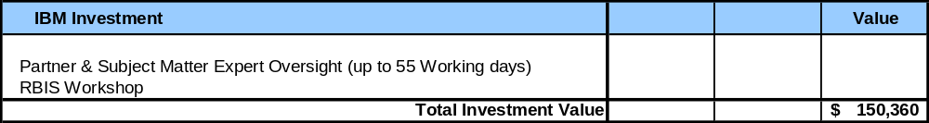
IBM proposes to perform select services including Business Intelligence Solution Consulting Partner Oversight throughout the 16 week project, Subject Matter Expertise associated with the process domains in the NSI scope, and facilitation of an IBM RBIS Solution Workshop. Gap will be billed actual travel and living costs associated with these services as detailed in section 4.1 “Project Pricing Estimates”.

Project Assumptions
Our estimates assume that Technical Architecture Components are selected by the end of phase 1 of the methodology and that the Technical Architecture and Strategy areas are completed as represented by the chart below:
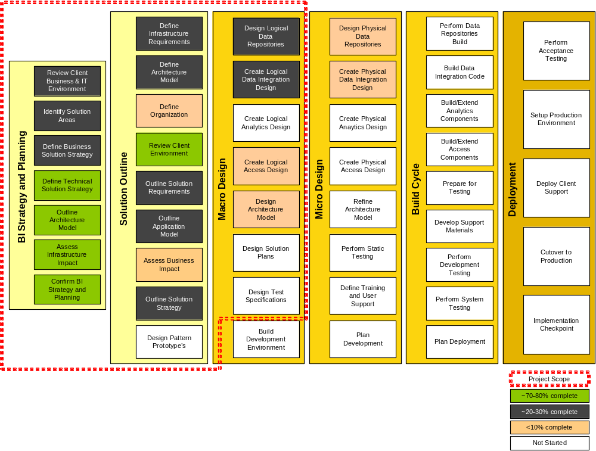

IBM requires the following Gap resources for the duration of the project:

- Project Manager (full-time)
- Project Sponsor (one day/week)
- Business Area SMEs (e.g. Finance, HR, Multi-channel) (1 per functional area 10% of time)
- IT Business functional area expertise consistent with the areas associated with NSI (1 per functional area, 50% of time) with one full time lead with knowledge of the current data sources
- Technical Architect to lead and own technical architecture and decisions
- Technical resources to drive architecture and design
- DBA to participate in design review and validation
- ETL personnel (one day/week to run record counts/reports, etc)
- Unix system administrator (full time initially during installs, 50% after installs completed)
- Establishment of a NSI BI steering committee within the first 6 weeks of the project.
- Timely review of deliverables with approval within 2 days of submission with only 1 review cycle
- Timely access to business and technical resources and associated documentation.

IBM Resources and Role Descriptions
Project Partner: Responsible for the overall delivery of the project and the relationship with Gap project sponsor.
Project Manager: Responsible for the delivery of the project and the day-to-day interface with the delivery team and Gap project manager.
BI Business Lead: Lead the review, collection and definition of reporting and analytic business requirements gathering. Identify key performance indicators in conjunction with end-to-end process workshops. Ensure business requirements are integrated into an NSI reporting and analytics solution. Recommend reporting process changes
BI Business Consultant: Support the review, collection and definition of reporting and analytic business requirements gathering. Identify key performance indicators in conjunction with end-to-end process workshops. Ensure business requirements are integrated into an NSI reporting and analytics solution. Recommend reporting process changes.

Technical Architect: IT professional that will lead the review of the overall architecture and assist with the development of the technical BI strategy including things like Metadata and testing approaches. Has experience with retail and BI architectural considerations.
Data Architect: IT professional with an appreciation of business content and BI architectural considerations that will assist with data mapping and source identification.

Project Resource Organizational Diagram
Below is the suggested project organizational structure.
